**Suhas Sunil Raut**

**SJSU ID: 011432980**

**Un-pipelined simulation result for IEEE floating point adder**:

99 + 178 = 277

277 – IEEE SP FP Format: **438A8000** (hex)

97 – 79 = 18

18 – IEEE SP FP Format: **41900000** (hex)

-55 + 75 = 20

20 – IEEE SP FP Format: **C3AE8000** (hex)

0 + 0 = 0

0 – IEEE SP FP Format: **00000000** (hex)

0 -113 = -113

-113 – IEEE SP FP Format: **C2E20000** (hex)

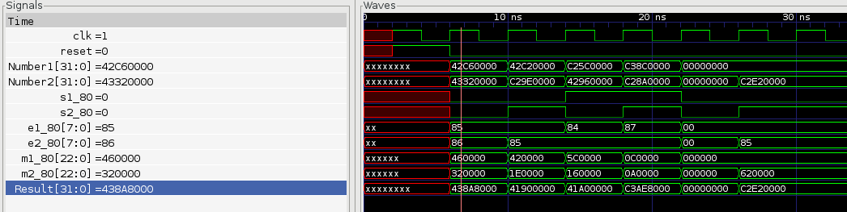

**Simulation Results for pipelined version of IEEE Floating point adder**:

Condition 1:

99 + 178

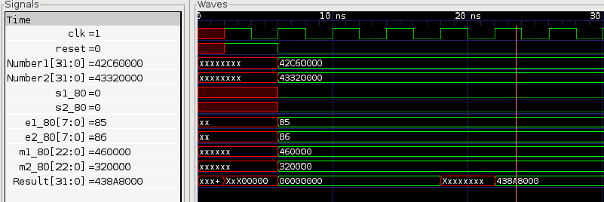

Condition 2:

97-79

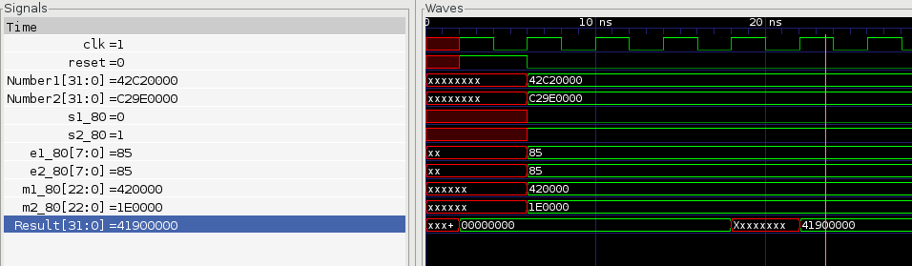

Condition 3:

-55 + 75

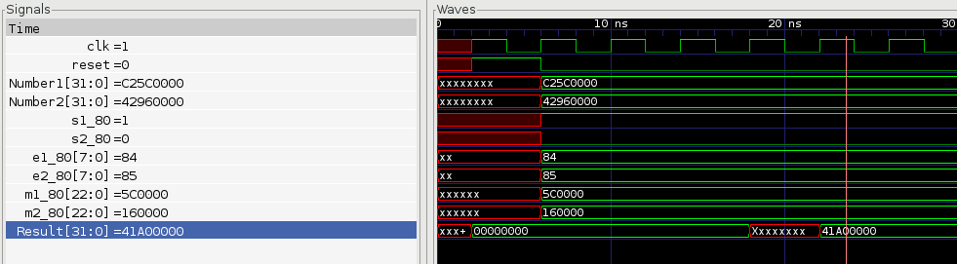

Condition 4:

-280-69

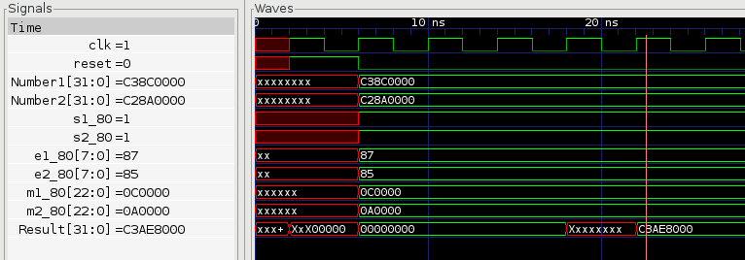

Condition 5:

0 + 0

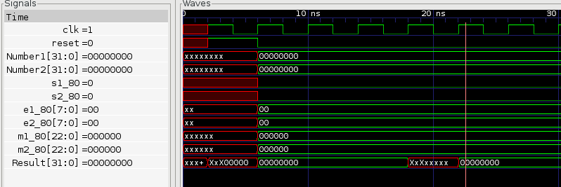

Condition 6:

0 – 113

